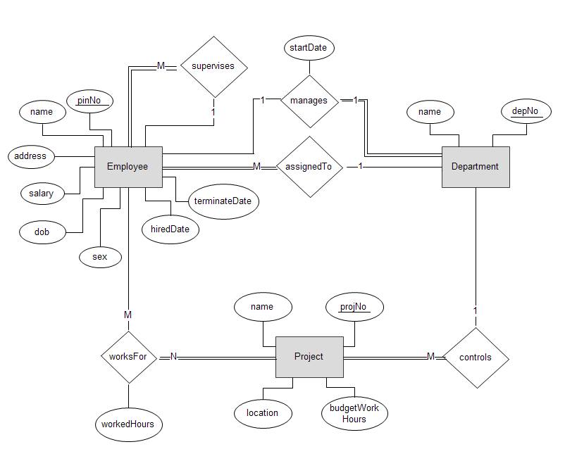

Tables:

**employee** : Id, superVisorId, name, add, salary, dob, sex, hiredDate,

terminateDate, deptId

**dept** : id, name

**manager** : employeeId, deptId, startDate

**project** : id, name, location, budgetWorkHours, deptId

**workingHours** : employeeId, projectId, workedHours

Relations:

**1:M** supervisor – employee (internal rel. as supervisor is an employee)

**1:M** dept – employee

**1:M** dept – project

**1:M** employee – manager

**1:M** dept – manager

**1:M** employee – workingHours

**1:M** project – workingHours